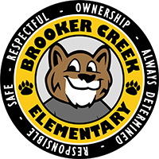BROOKER CREEK ELEMENTARY SCHOOL

**4th Grade**

2025-2026 4th Grade Supply List

**The following items are needed:**

* Qty of 2- 1 inch 3-ring binder with clear view pocket
* Qty of 2- ½ inch 3-ring binder with clear view pockets
* 4 Plastic folders WITH prongs (1 of EACH color: red, blue, yellow, green)
* 1 Subject spiral notebook (1 blue and 2 green)
* 1 Composition notebook
* 1 Pack wide-ruled notebook paper
* 8 Black Expo markers
* 8 Pack glue sticks
* 50 Pack clear page protectors
* Scissors
* 2 Black sharpies
* 1 Pack cap erasers
* 48 Count pre-sharpened pencils
* 2 Highlighters
* Headphones with USB port or USB adapter
* 2 Packs of 12 colored pencils
* 8 Pack of markers
* 2 Boxes of tissues

**Optional items we would love:**

* Sticky notes (3x3, 4x6, and larger)
* 1 or more container of disinfectant wipes
* 1 Bottle of liquid hand soap
* 1 Bottle of hand sanitizer with pump
* Ziploc bags- any size
* Treasure box items
* Cardstock paper (white and/or brights/multicolored)
* Band-aids